Depth First Search (DFS) is a core AI algorithm for traversing or searching through tree or graph structures by exploring each branch as deeply as possible before backtracking to explore alternate paths. DFS is widely used in artificial intelligence for problem-solving, pathfinding, and analyzing possible states.

**Essential context and details:**

* **Traversal Pattern:** DFS starts at a root node, expands one branch down as far as it can go (to a “leaf” or dead end), then backtracks to explore the next branch. This process is repeated until all nodes are visited or a solution is found.
* **Implementation:** DFS can be implemented recursively or using a stack data structure. The stack keeps track of unexplored nodes, enabling the algorithm to remember the path and backtrack when needed.
* **Algorithm Steps:**
  + Mark the current node as visited.
  + For each unvisited neighbor, recursively (or iteratively) apply DFS.
  + If a node has no unvisited neighbors, backtrack to the previous node.
* **Time and Space Complexity:** For a graph with V vertices and E edges, DFS has time complexity O(V+E)*O*(*V*+*E*) and space complexity O(V)*O*(*V*).
* **Applications in AI:** DFS is commonly used for state space search, puzzle-solving, pathfinding, cycle detection, topological sorting, and analyzing connectivity in AI tasks.

**Key characteristics:**

* DFS is not guaranteed to find the shortest path in unweighted graphs.
* Depending on implementation and graph structure, DFS can get stuck in deep or infinite branches if not carefully handled (e.g., with visited node checks).
* Its memory requirements are generally low compared to Breadth First Search, as it stores only the current path from the root to the leaf.

DFS is fundamental to many search-based AI problems and is a building block for more sophisticated algorithms.

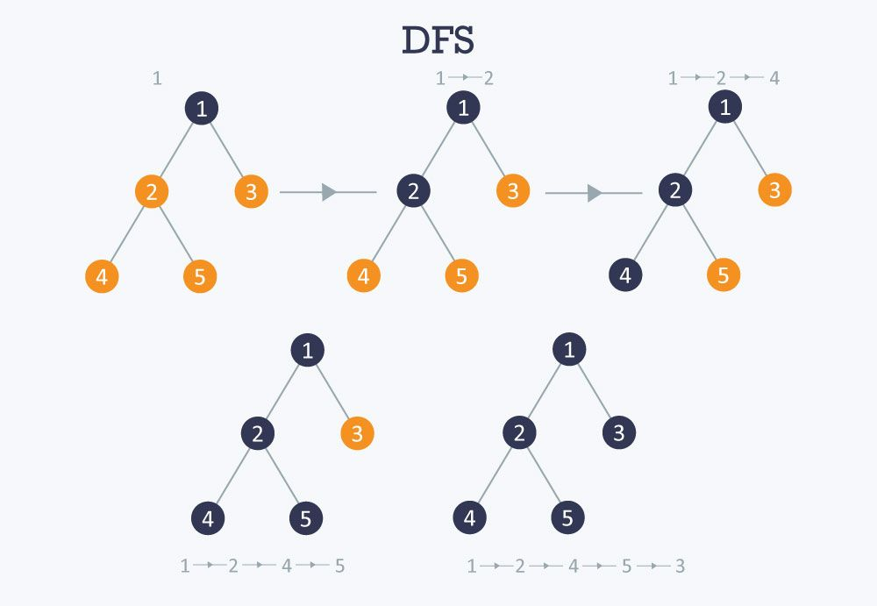

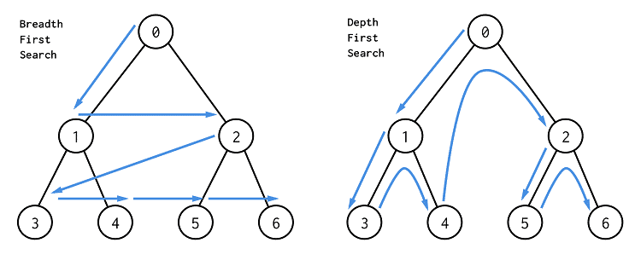

**Real World Applications:**

* **Cycle Detection in Graphs:** DFS helps identify cycles in both directed and undirected graphs, useful in deadlock detection for operating systems and identifying circular dependencies in databases or software projects.
* **Topological Sorting:** DFS is used for ordering tasks based on dependencies, such as determining the build order in software compilation, resolving prerequisite chains for course scheduling, and automating instruction sequences in spreadsheets.
* **Pathfinding in Maps and Robotics:** DFS can be used for finding paths in maps, solving mazes, and for navigation in robotics, where exploring all possible routes or solutions may be needed, especially when memory resources are limited.
* **Web Crawlers:** DFS allows crawler bots to explore web links deeply, diving into one branch of a website exhaustively before backtracking, which is useful for indexing content on complex websites.
* **Connected Components in Networks:** DFS helps identify groups or clusters within social networks, communication networks, or biological networks, showing which entities are interconnected.
* **Puzzle Solving and Games:** DFS is used to systematically explore all possibilities in puzzles (like mazes, Sudoku, or logic games) and game trees, forming the foundation for more advanced AI strategies and decision-making (e.g., Minimax for games like chess and tic-tac-toe).
* **Maze Generation:** Randomized DFS is popular for generating new maze layouts, ensuring each area is accessible and the solution is unique.
* **Model Checking/Verification:** In formal verification, DFS explores all possible states in a system to ensure they meet certain properties, assisting in software and hardware quality assurance.
* **Backtracking Algorithms:** DFS serves as the backbone for constraint-solving and backtracking problems (such as the N-Queens problem, crossword puzzles, and combinatorial search problems).